Week Ending: | DAY: |  |  |  | Subject: Science
Duration: 60mins per lesson |  |  |  |  | Strand: Humans & The Environment
Class: B5 | Class Size: |  |  |  | Sub Strand: Science and Industry
Content Standard:  B5.5.3.1 Recognize the impact of science and technology in society |  |  | Indicator:  B5.5.3.1.1 Identify the raw materials used in some local industries |  |  | Lesson:  1 OF 1
Performance Indicator:  - Learners can identify the raw materials used in some local industries |  |  |  | Core Competencies:  Problem Solving skills; Critical Thinking; Justification of Ideas;
Teaching/ Learning Resources |  | Gari, kenkey, shea butter, cooking oil, blacksmith, basketry
References: Science Curriculum Pg. 31
DAYS | PHASE 1: STARTER | PHASE 2: MAIN | PHASE 3: REFLECTION
 | Teacher introduces the lesson to learners. Students are to list all the words they associate with the topic to be treated.  Ask them to put words together to form a definition | Take learners to a local basketry or pottery production site or show videos of such ventures.  Learners observe critically and identify the raw materials used in the various industries.  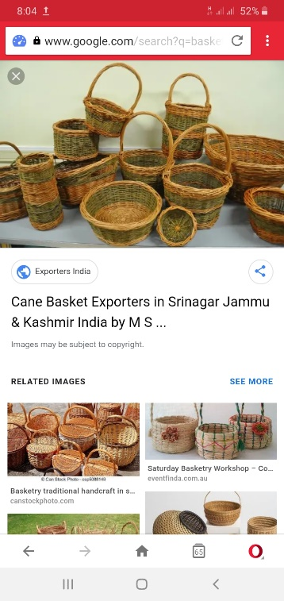  Engage the learners in a matching activity to match some local products with their raw materials. | Ask learners questions to review their understanding of the lesson.  Have learners write 3 facts of the lesson on a sheet of paper and it in their pockets and learn it on their way home.
 | Teacher writes and lets students see the answer on the board, perhaps a picture of object on the board.  The students must come up with questions in which the answer could be the object on the board. | Take learners to a local carpentry site or show videos of such ventures.  Learners observe critically and identify the raw materials used in the carpentry industry  Learners plan and design a factory in their locality, showing the raw materials they use and the finished products | Ask learners questions to review their understanding of the lesson.  Have learners write 3 facts of the lesson on a sheet of paper and it in their pockets and learn it on their way home.  Next lesson: Identify the impact of deforestation on climate change

